**LAB ASSIGNMENT**

**Interest Rate + Principal Calculator**

**Create a program that will that will calculate Yearly Interest or Compound Interest on a starting principal. The program will output the results to a text file.**

**Accept user input in dollars$ in main(). Program should not run if dollar amount > 0. Prompt user and exit the program.)**

**All the user to choose Yearly Interest Calculation or Compound Interest Calculator**

**Break program into TRUE OOP design. Use class with, setter, and getter methods to solve the problem.**

**Look to minimize the code in main. Code should begin to only operate the program similar to previous assignments built around multiple functions.**

**\*\*\*\*\*\*\*\*\*\*\*\*\*\*\*\*\*\*\*\*\*\*\*\*\*\*\*\*\*\*\*\*\*\*\*\*\*\***

**\* Main Menu: \***

**\* Enter # to run program or Quit \***

**\* 1) Yearly Interest Calculator \***

**\* 2) Compound Interest Calculator \***

**\* 3) Quit \***

**\*\*\*\*\*\*\*\*\*\*\*\*\*\*\*\*\*\*\*\*\*\*\*\*\*\*\*\*\*\*\*\*\*\*\*\*\*\***

**Break program into TRUE OOP design. Use class with, setter, and getter methods to solve the problem.**

1 argument will represent **savings**

1 argument will represent **years.**

1 argument will represent **interest rate.**

**Sample:**

Please enter $ in savings.

3334

Please enter number of years

3

Please enter interest rate

1.0

Year 1 = $3367.34

Year 2 = $3401.01

Year 3 = $3435.02

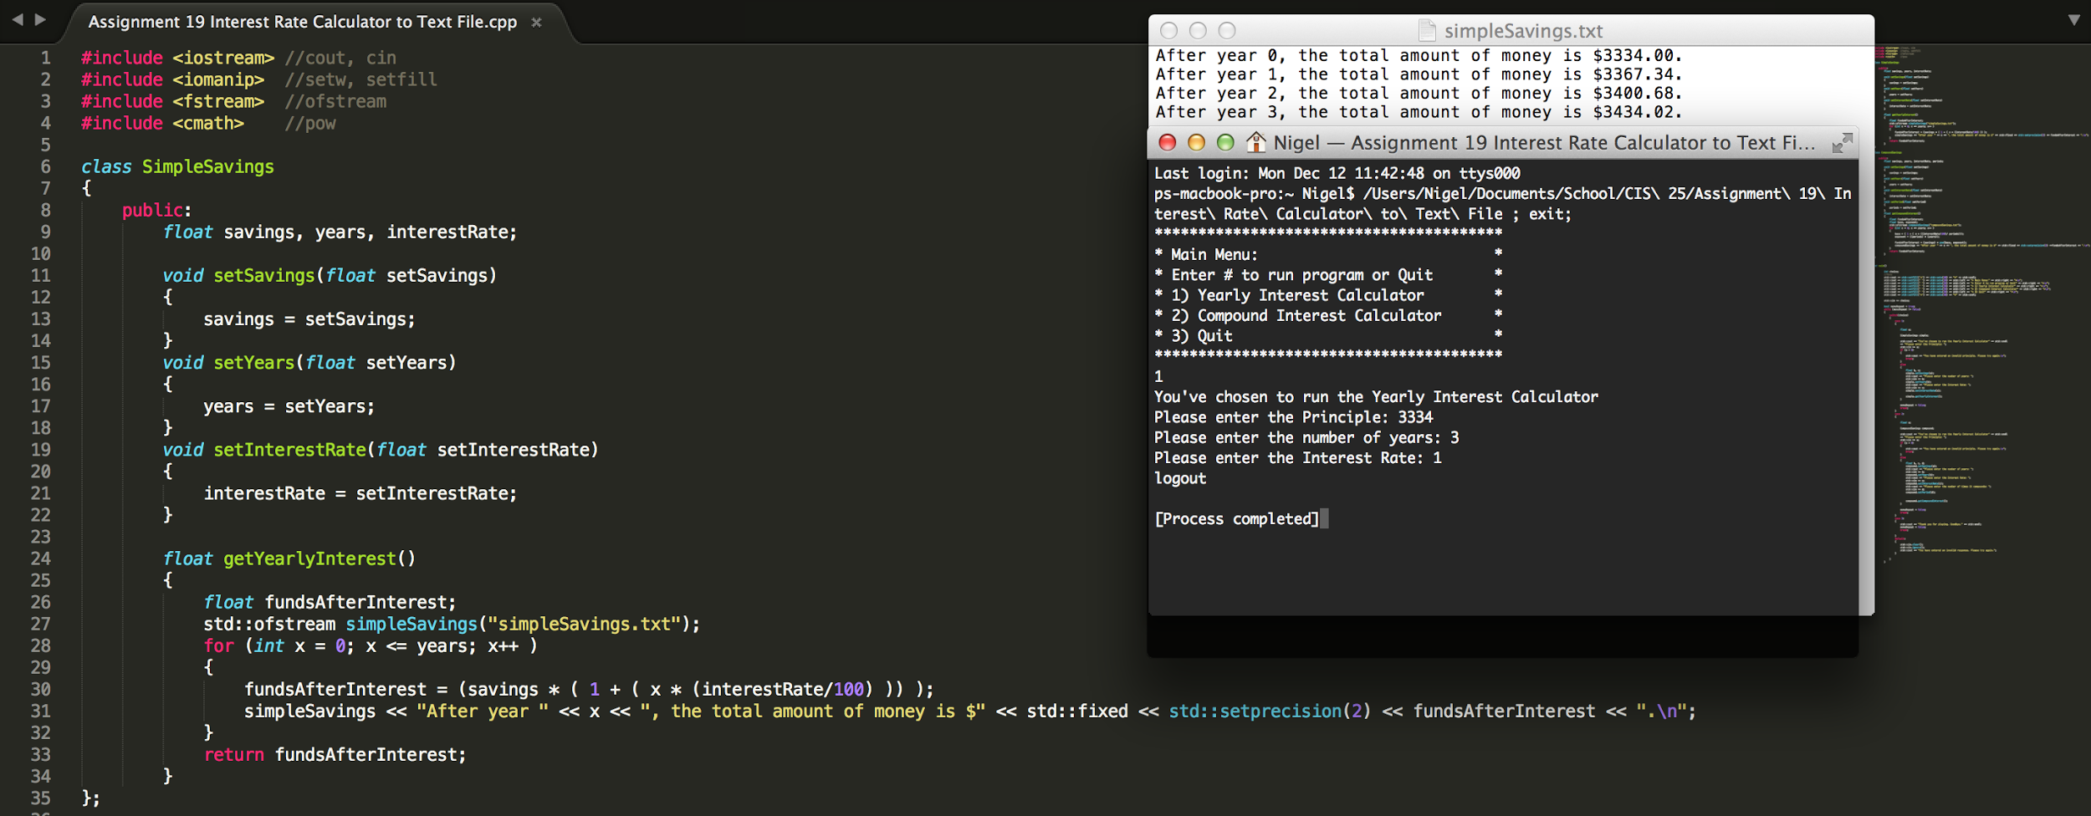

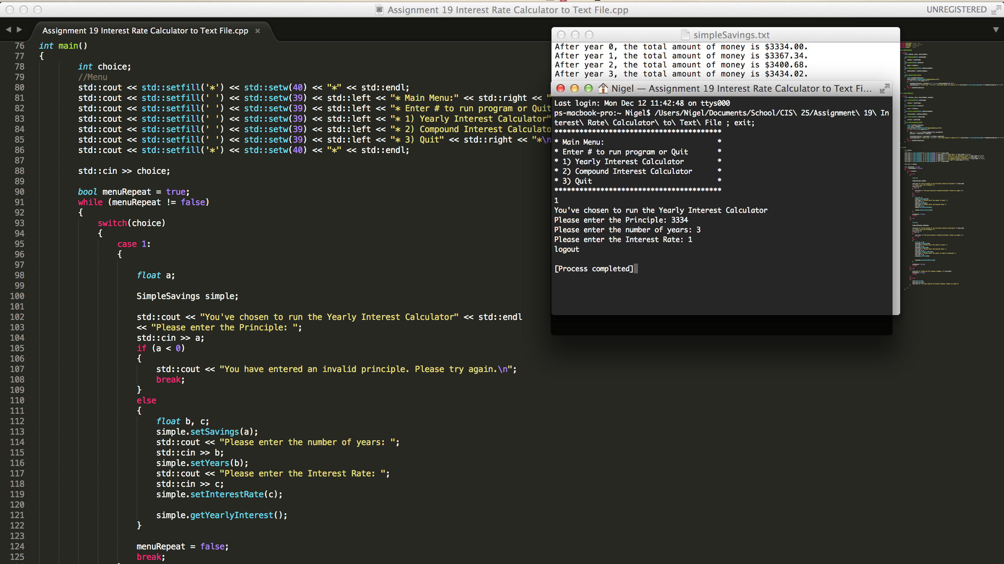

**Break program into TRUE OOP design. Use class with, setter, and getter methods to solve the problem.**

Please enter $ in savings

3334

Please enter number of years

1

Please enter interest rate

1.0

Number of times compounded

3

Principle Compounded 1 = $3367.34

Principle Compounded 2 = $3401.01

Principle Compounded 3 = $3435.02

